Student 1:

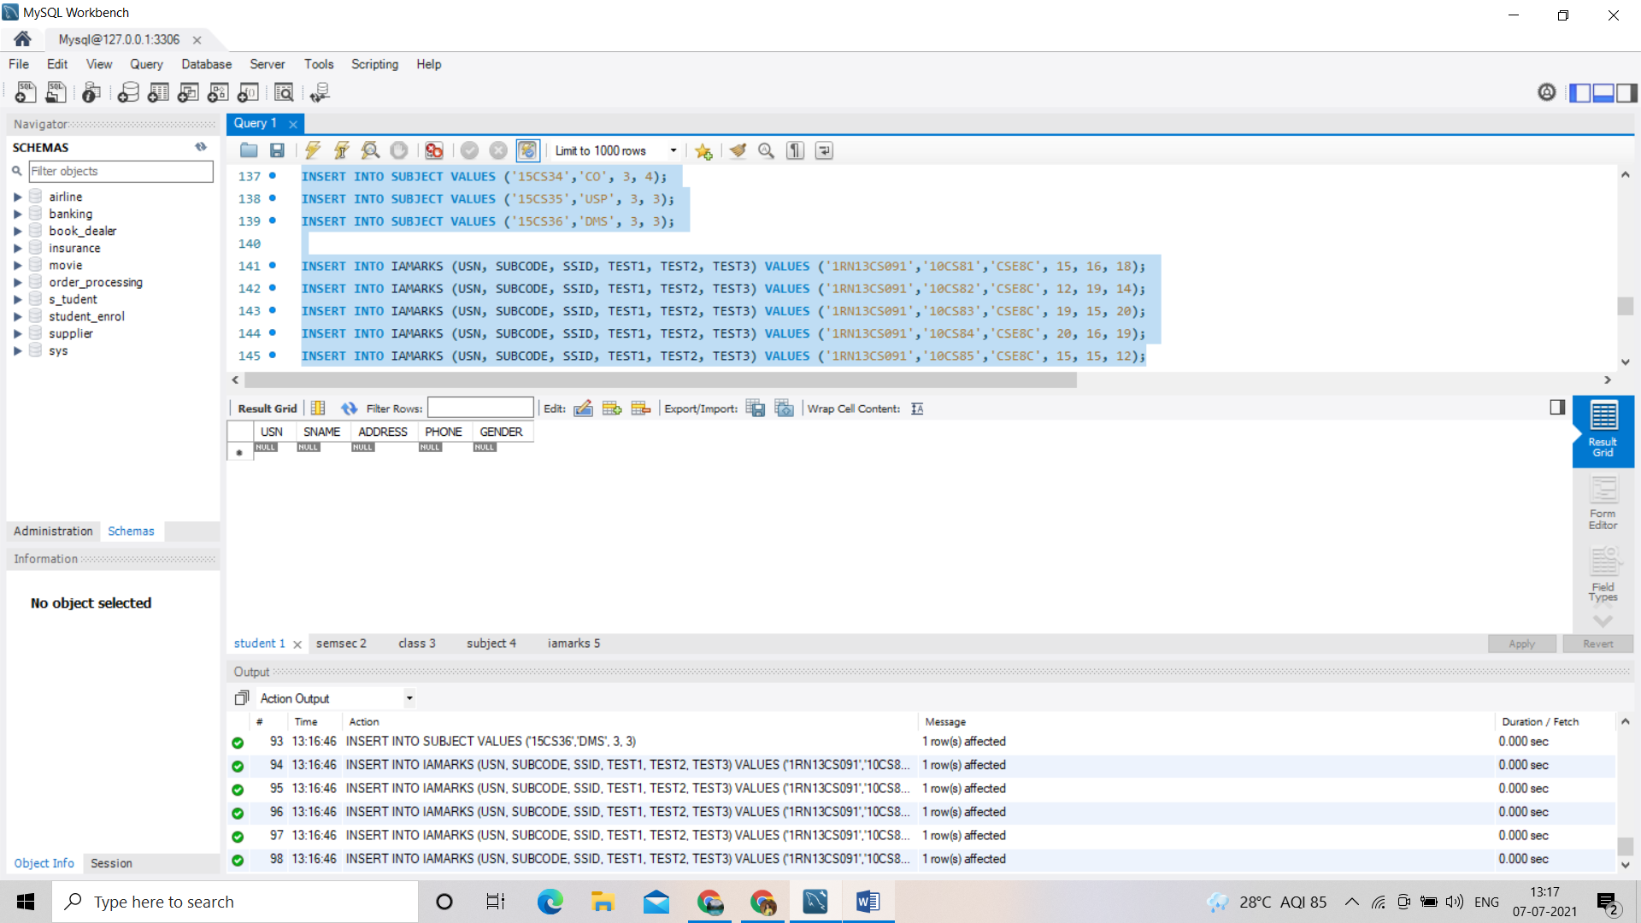

Semsec 2:

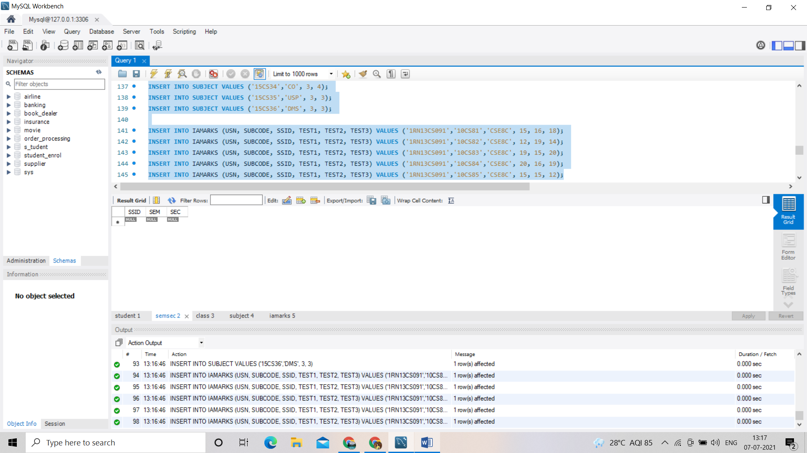

Class 3:

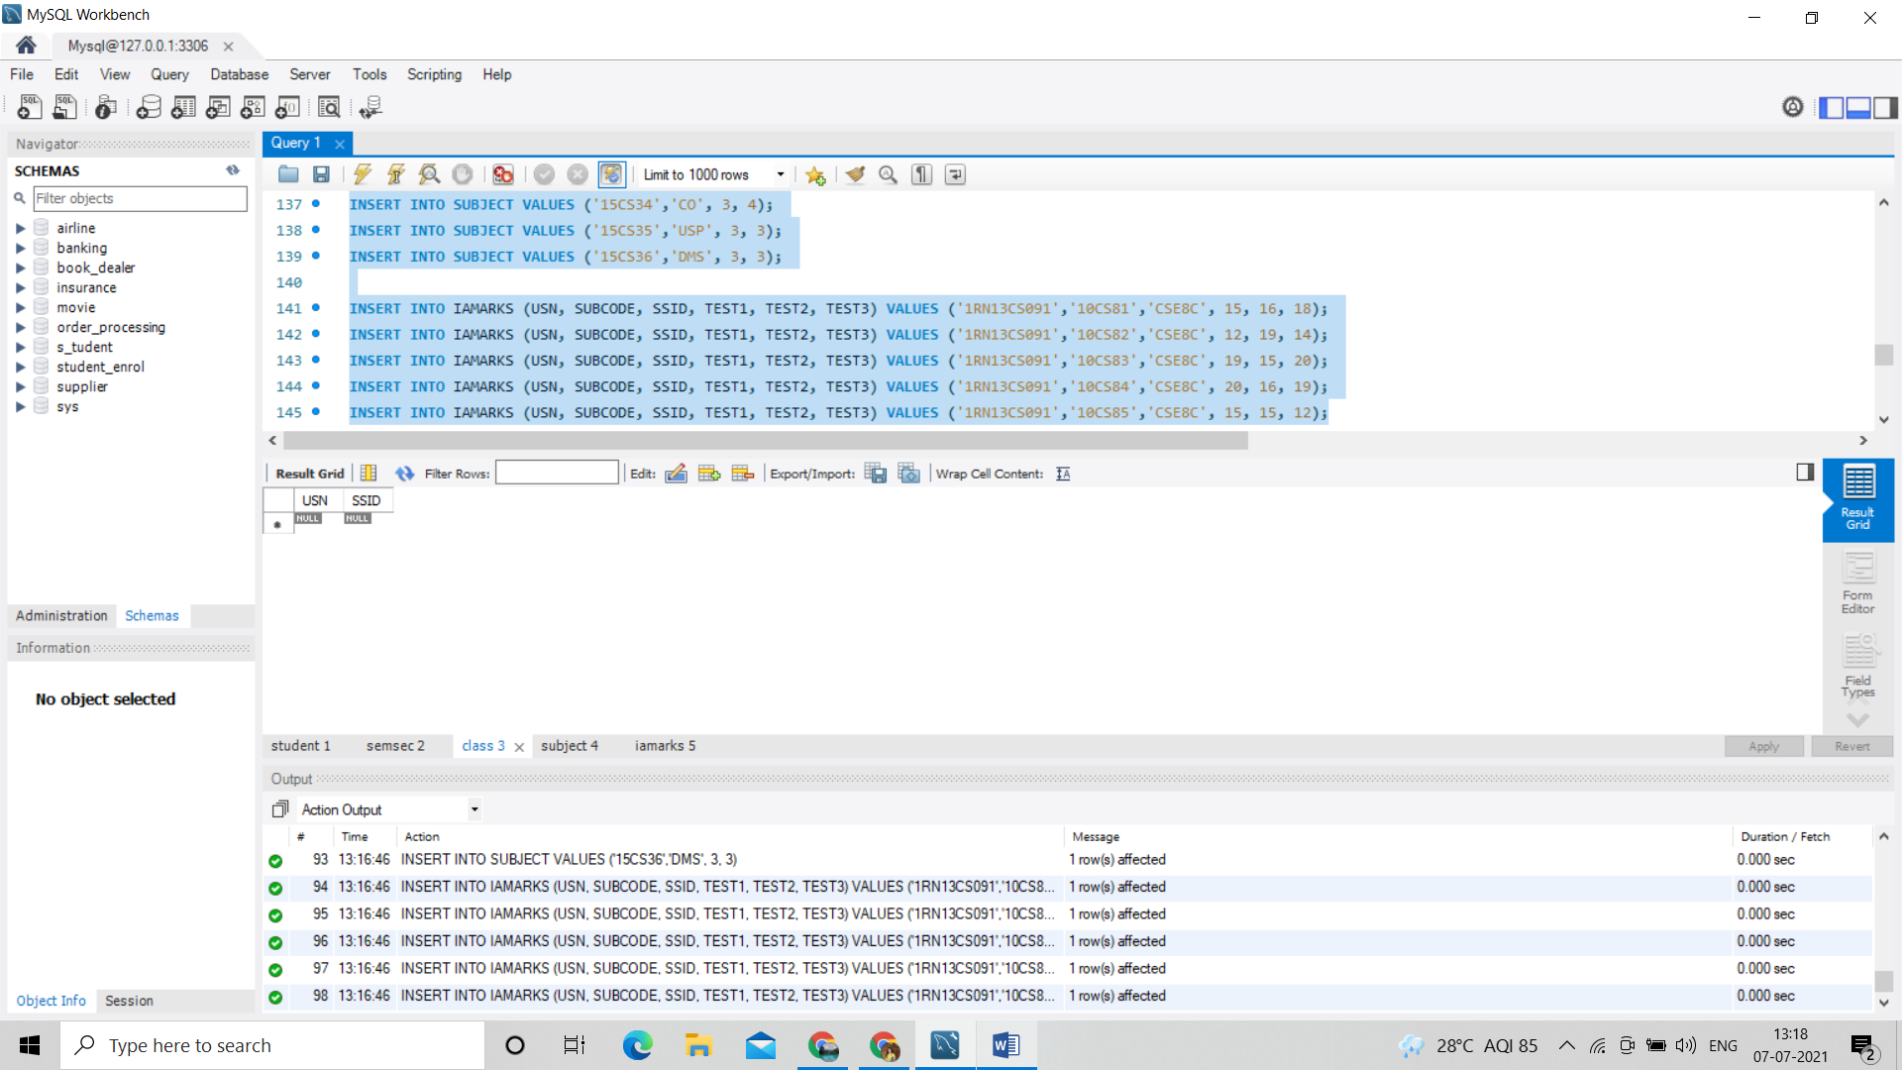

Subject 4:

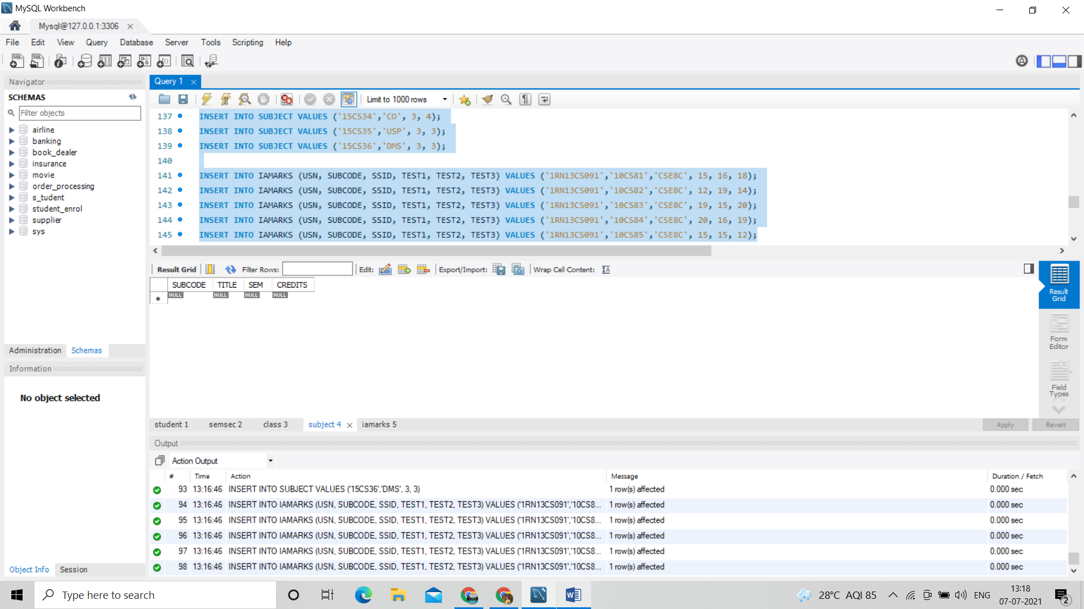

Iamarks 5:

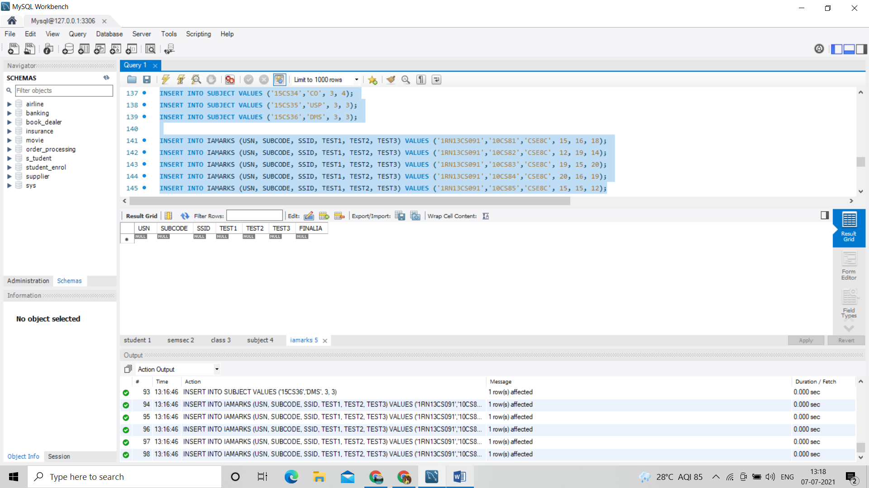

Query 1:

SELECT S.*, SS.SEM, SS.SEC

FROM STUDENT S, SEMSEC SS, CLASS C

WHERE S.USN = C.USN AND

SS.SSID = C.SSID AND

SS.SEM = 4 AND SS.SEC='C';

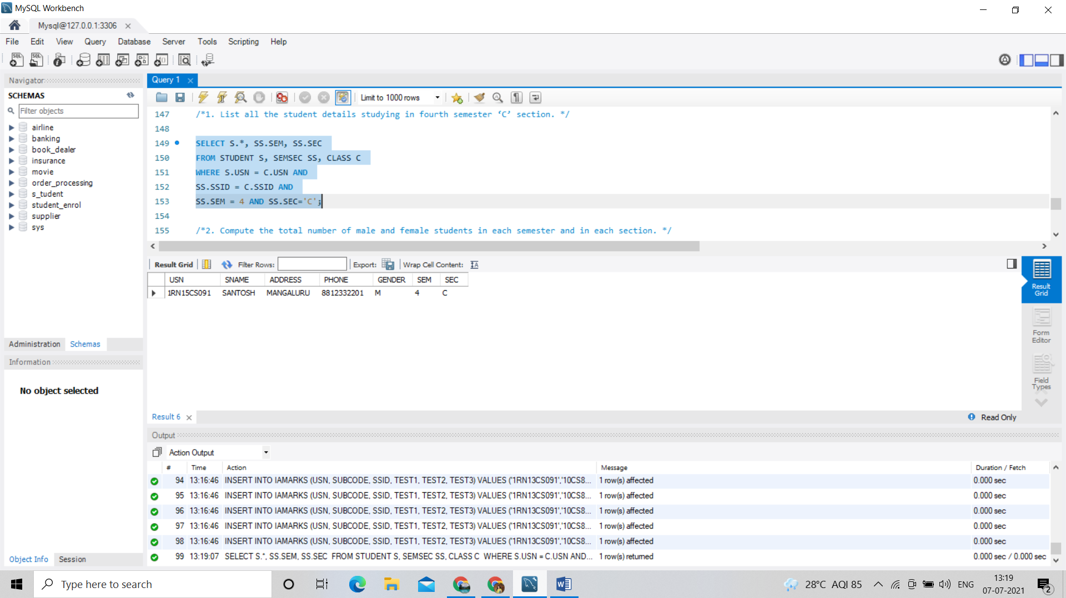

Query 2 :

SELECT SS.SEM, SS.SEC, S.GENDER, COUNT(S.GENDER) AS COUNT

FROM STUDENT S, SEMSEC SS, CLASS C

WHERE S.USN = C.USN AND

SS.SSID = C.SSID

GROUP BY SS.SEM, SS.SEC, S.GENDER

ORDER BY SEM;

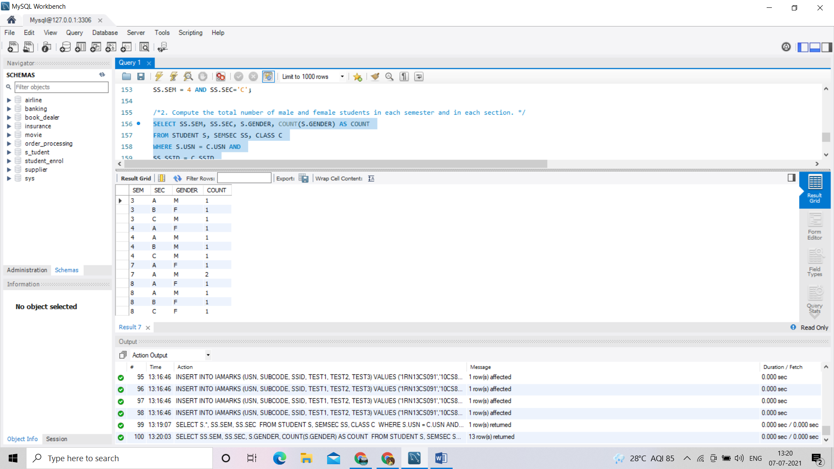

Query 3:

CREATE VIEW STU_TEST1_MARKS_VIEW

AS

SELECT TEST1, SUBCODE

FROM IAMARKS

WHERE USN = '1RN13CS091';

SELECT * FROM STU_TEST1_MARKS_VIEW;

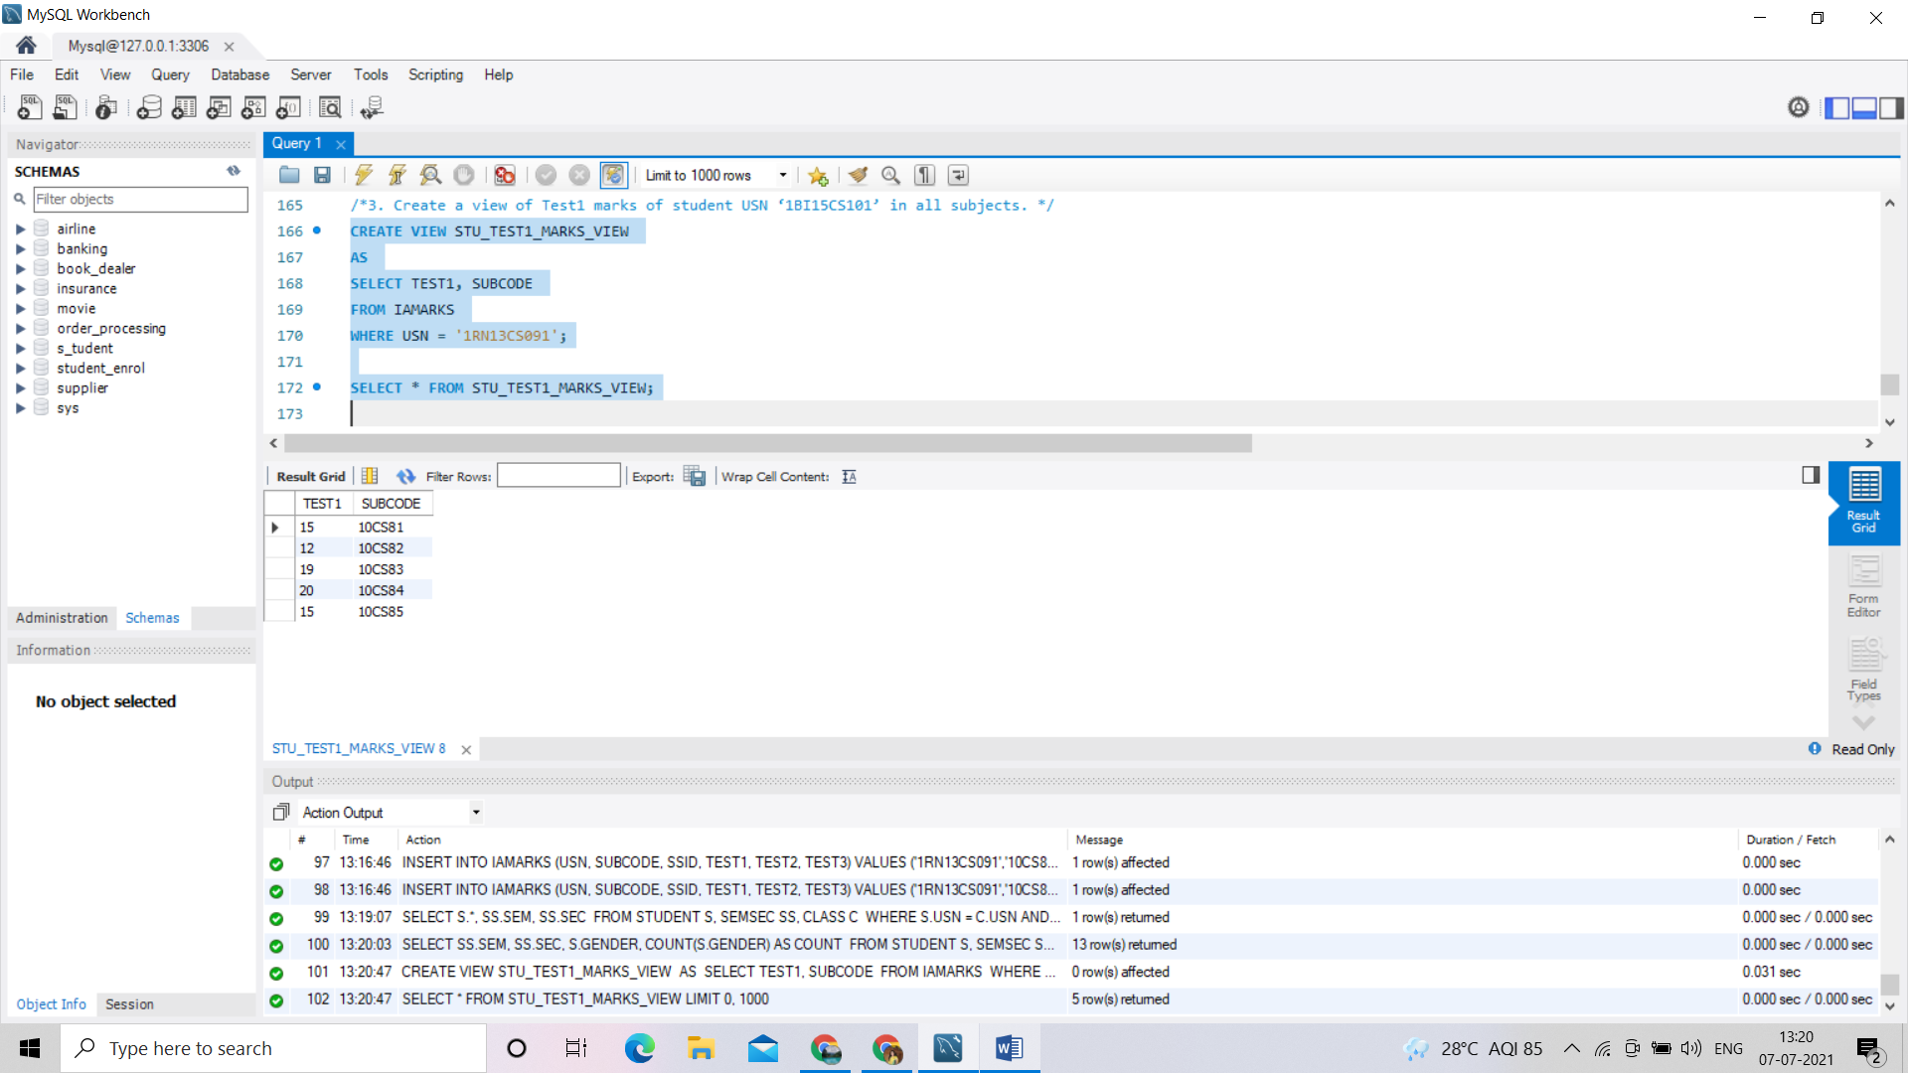

Query 4:

SELECT S.USN,S.SNAME,S.ADDRESS,S.PHONE,S.GENDER,

(CASE

WHEN IA.FINALIA BETWEEN 17 AND 20 THEN 'OUTSTANDING'

WHEN IA.FINALIA BETWEEN 12 AND 16 THEN 'AVERAGE'

ELSE 'WEAK'

END) AS CAT

FROM STUDENT S, SEMSEC SS, IAMARKS IA, SUBJECT SUB

WHERE S.USN = IA.USN AND

SS.SSID = IA.SSID AND

SUB.SUBCODE = IA.SUBCODE AND

SUB.SEM = 8; 